

Practices for Secure Software Report

Table of Contents
Document Revision History 3
Client 3
Instructions 3
Developer 4
1. Algorithm Cipher 4
2. Certificate Generation 4
3. Deploy Cipher 4
4. Secure Communications 4
5. Secondary Testing 4
6. Functional Testing 4
7. Summary 4
8. Industry Standard Best Practices 4

Document Revision History

Version | Date | Author | Comments
1.0 | 04/19/2026 | Kerene Milele

Client



Instructions

Submit this completed practices for secure software report. Replace the bracketed text with the relevant information. You must document your process for writing secure communications and refactoring code that complies with software security testing protocols.

- Respond to the steps outlined below and include your findings.
- Respond using your own words. You may also choose to include images or supporting materials. If you include them, make certain to insert them in all the relevant locations in the document.
- Refer to the Project Two Guidelines and Rubric for more detailed instructions about each section of the template.

Developer
Kerene Milele

Algorithm Cipher

After reviewing Artemis Financial’s need to protect long-term archive files, I recommend using the Advanced Encryption Standard (AES), specifically AES/GCM/NoPadding with a 256-bit key. AES is a strong and trusted encryption standard, and Oracle lists it as a standard Java cipher algorithm (Oracle, n.d.). This makes it a good choice for Artemis Financial because the company needs to protect sensitive financial records for a long time.

Hash functions are important because they turn data into a fixed-size value. SHA-256 produces 256-bit hash and is commonly used for checksum verification. Encryption and hashing are not the same. Encryption protects data so it can be read only by authorized users, while hashing helps verify integrity. Modern encryption also depends on secure key management, strong random values, and good implementation practices. Symmetric encryption uses one shared key, while asymmetric encryption uses a public and private key pair.

Certificate Generation

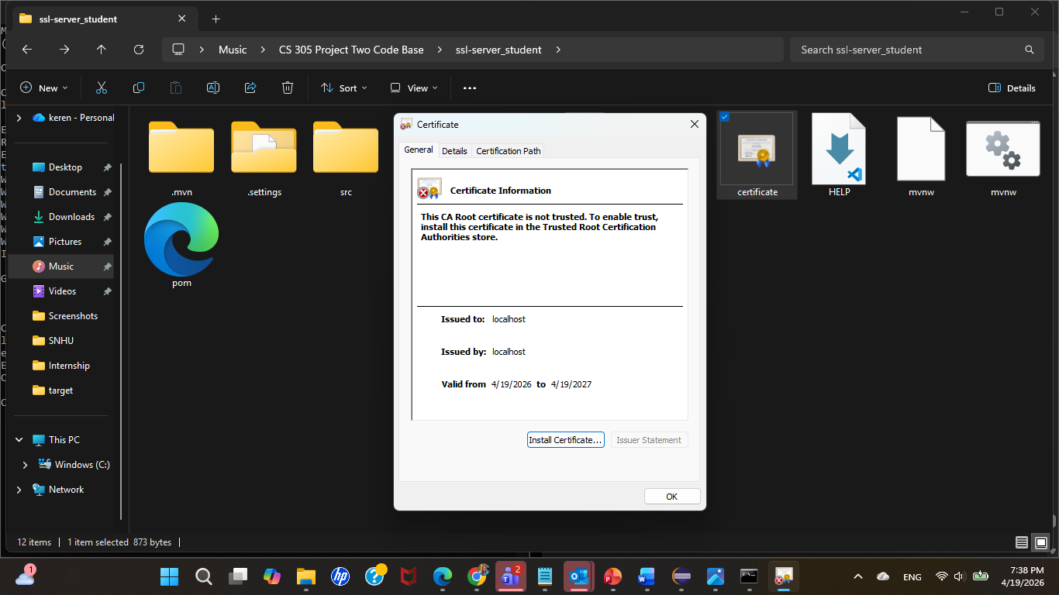
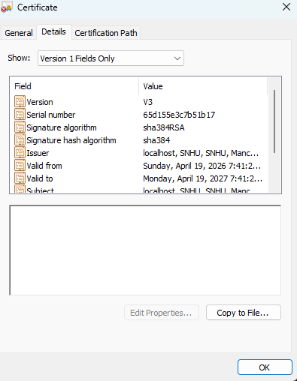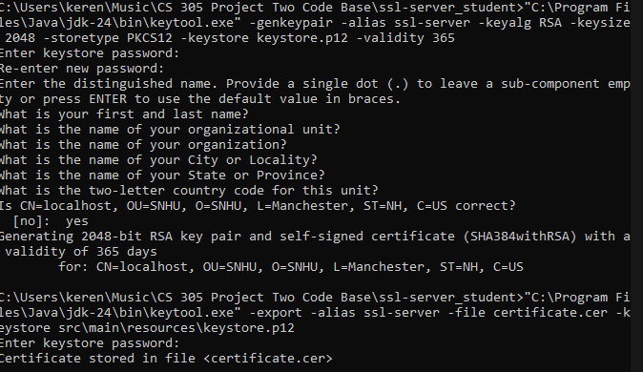

Deploy Cipher
Insert a screenshot below of the checksum verification.

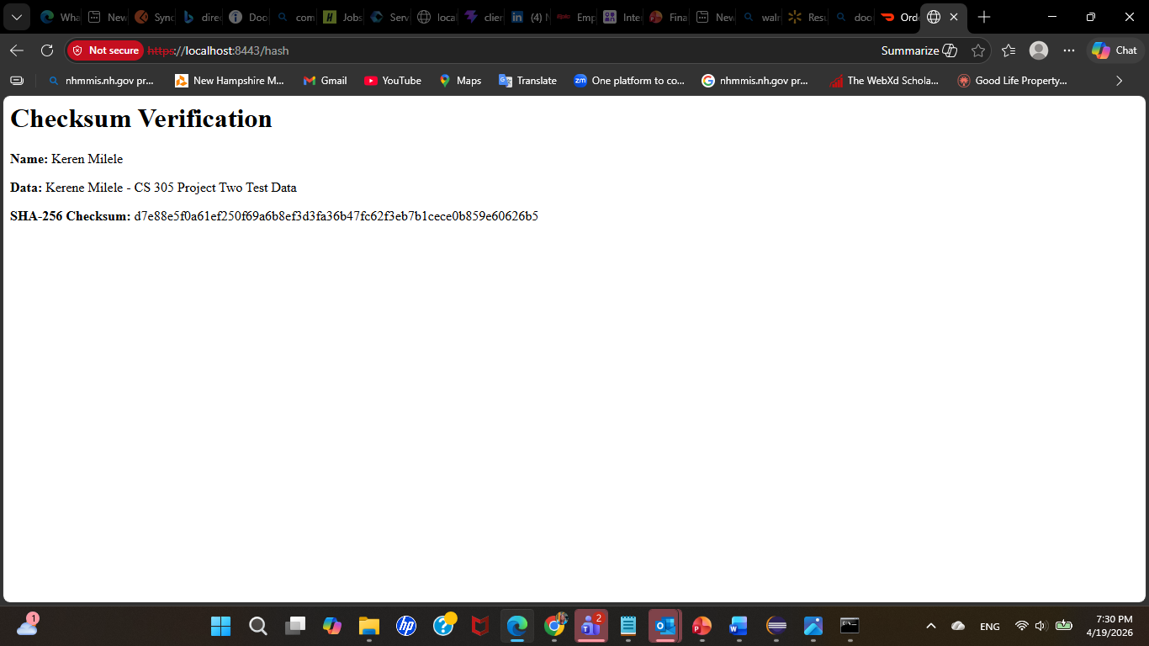

Secure Communications
Insert a screenshot below of the web browser that shows a secure webpage.



Secondary Testing

I ran OWASP Dependency-Check after refactoring the application. The code compiled successfully, the unit test passed, and the project built correctly. At first, the dependency-check scan had problems because the older plug-in version could not fully work with the vulnerability feed. I updated the dependency-check version to 12.1.1 and reran the scan. After that, I was able to review the output report for dependency vulnerabilities.
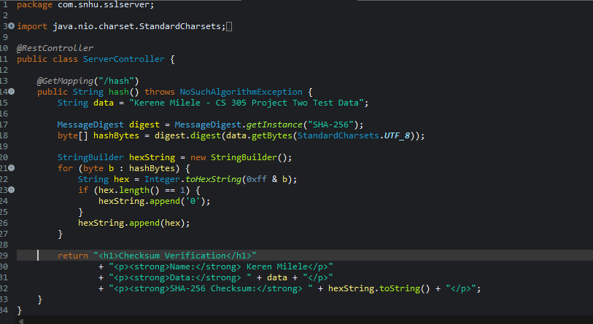

Functional Testing
I manually tested the application after refactoring the code. First, I ran the Spring Boot application and confirmed that it started without errors. Then I opened the secure browser page at https://localhost:8443/hash and confirmed that the application used HTTPS correctly. I also verified that the checksum page displayed my name, a unique data string, and the SHA-256 checksum result.



Summary

I improved the Artemis Financial application by adding a checksum feature with SHA-256, creating a self-signed certificate, and changing the application from HTTP to HTTPS on port 8443. These changes made the program more secure because they help protect the connection between the browser and the server and they also help confirm that the data has not been changed. After making the updates, I tested the program and confirmed that the secure page and checksum page both worked correctly.

In this project, I focused on important security areas like cryptography, secure communication, and safe coding practices. I also used manual testing and dependency-check to review the application after refactoring it. Overall, the project showed how adding a few security layers can make software safer and more reliable, especially for a company like Artemis Financial that works with sensitive financial information.

Industry Standard Best Practices

In this project, I followed common secure coding practices that developers use in real software projects. I used HTTPS to protect communication, created a certificate for secure connections, and used SHA-256 to verify data with a checksum. I also tested the application after making changes and reviewed the dependencies to look for possible security problems. These steps helped me improve security without breaking the application.

Using secure coding best practices is important because it helps protect private customer information and lowers the chance of security problems later. For Artemis Financial, this matters a lot because the company handles sensitive financial data. When developers follow good security practices from the beginning, the software becomes more trustworthy, more stable and safer for both the company and its customers.

